GP Opportunity

Assynt Medical Practice
Assynt, Northwest Highlands, Scotland

‘Do you want to be a valued member of a stable, collaborative team, offering high quality, varied medical care to a supportive,
appreciative community of patients in a spectacular setting?’

We are a remote and rural Practice located in the picturesque coastal village of Lochinver. Surrounded by stunning scenery and wildlife, Lochinver is around 2 hours’ drive Northwest of Inverness, on the now-famous North Coast 500 route. We endeavor to provide realistic, holistic family medicine to our cohesive but geographically widely dispersed population, whilst retaining a healthy balance between work and life.

We are seeking an enthusiastic clinician to join our friendly, well-established Practice team. We welcome applications from candidates at all stages of their GP career; sessions can be flexible and job share requests will be considered and a team player passionate about multidisciplinary General Practice. We have well established supportive and educational links with secondary care and wider multidisciplinary colleagues within the community. Additionally, we have a valued and stable administrative and dispensing team who are very supportive of our clinicians and have invaluable local knowledge.

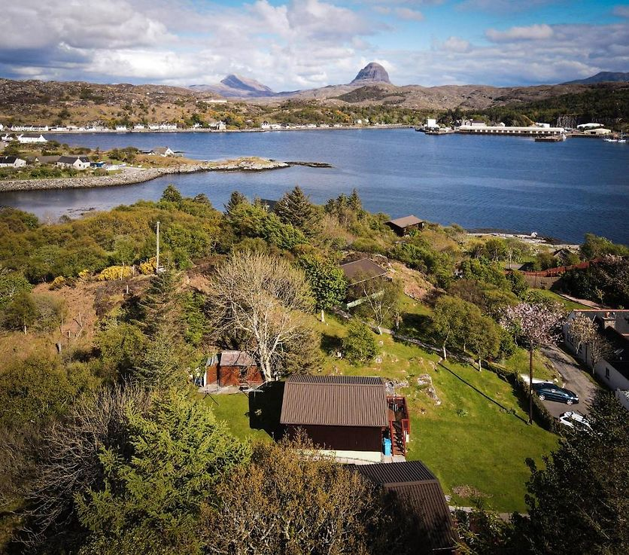

The position:
- GMS Practice: 1000 patients with 2 GP Partners, 1 Health Care Assistant, First Contact Physiotherapist, Community Psychiatric Nursing Team (including Support Worker), Community Nursing Team, Occupational Therapist, weekly visiting NHS Dental Team.
- Competitive salary, indemnity cover provided.
- Affordable accommodation is available as required
- Generous annual leave, ten public holidays and one week study leave, sabbatical leave every 5 years for Partners.
- Paperless Vision clinical system and Docman, active participant in our Cluster. 15min appointments as standard.
- Supportive of outside interests and portfolio careers. We currently participate in Medical Education in the form of Medical Students from UK wide Universities and Research projects, in addition to supporting rotating 3 month placements for Ministry of Defence GP trainees.
- Golden Hello and relocation package subject to availability.
- Out of Hours commitment currently covering 8am Monday to 6pm Friday, but flexible if not desired.
- Primary school in Lochinver and high achieving Secondary school in Ullapool (1hr away by school transport)
- Excellent local amenities – leisure centre, shops, restaurants, cafes - and supportive local community.
- Superb lifestyle opportunities for out-door pursuits including water sports, hiking, fishing and wildlife spotting.

The person:
- Are you committed to taking a holistic approach to high quality patient care/family medicine?
- Do you communicate effectively at all levels and appreciate the value of excellent teamwork?
- Have you special interests, a clinical area in which you would like to pursue/develop your skills?
- Would you like to work in a rural practice, surrounded by outstanding natural beauty that encourages work life balance?
- Do you believe in continued professional development and are confident in managing yourself and others?

The job information pack is available under the ‘recruitment’ tab on our practice website www.assyntmedicalpractice.org/recruitment/ or scan the QR code below. To apply, please post or email your CV and cover letter to:

Dr Sarah Donald
GP Partner
Assynt Medical Practice
Lochinver
Lairg
IV27 4JZ
E-mail: sarah.donald@nhs.scot
Tel: 01571 844755

Alternatively, if you’d like to chat about the role or to arrange a visit to the practice, please get in touch with Dr Sarah Donald, details above.

www.assyntmedicalpractice.org/recruitment/

